**LCM**  
  
**AIM:**To write an assembly language program to implement prime number using 8085 processor.  
**ALGORITHM:**  
1)   Start the program by loading a register pair with address of 1st number.  
2)   Copy the data to another register pair.  
3)    Load the second number to first register pair.  
4)    Subtract the two register pair contents.  
5)    Check for borrow.  
6)    Store the value of difference and borrow in memory locations.  
7)    End.   
**PROGRAM:**

**LXI H,8000**

**MVI C,M**

**MVI B,00**

**INX H**

**MOV A,M**

**CMA**

**MOV E,A**

**;MVI D,FF**

**MOV A,B**

**CMA**

**MOV D,A**

**INX D**

**LXI H, 0000**

**NEXT: DAD B**

**SHLD 8002**

**LOOP: DAD D**

**JNC SKIP**

**MOV A,H**

**ORA L**

**JZ EXIT**

**JMP LOOP**

**SKIP: LHLD 8002**

**JMP NEXT**

**EXIT: LHLD 8002**

**HLT**

INPUT:

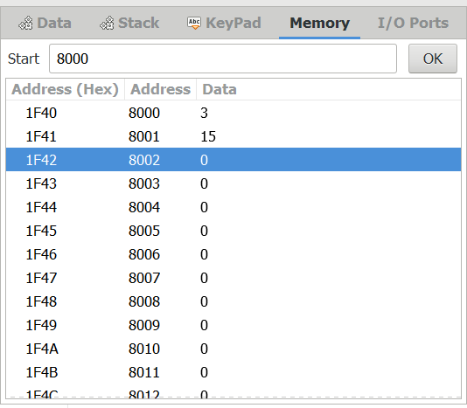

OUTPUT:

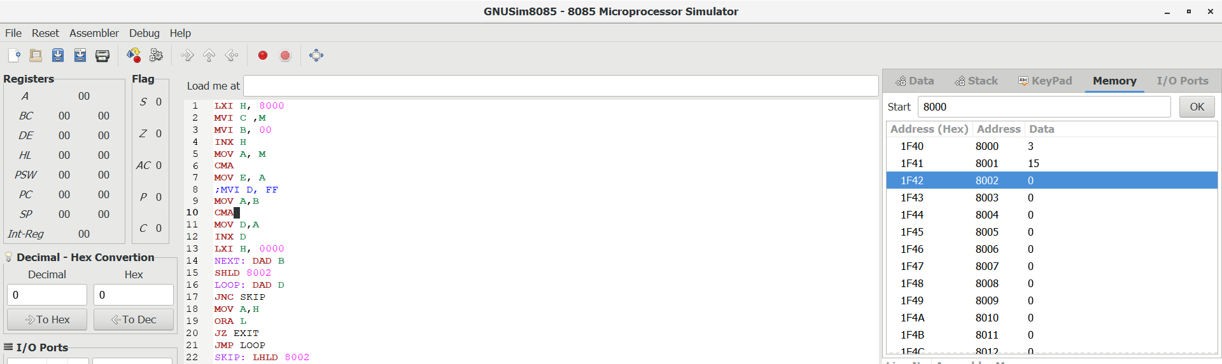

RESULT:

Thus the program was executed successfully using 8085 processor.